25.33: a) An ideal voltmeter has infinite resistance, so there would be NO current through the 
b) 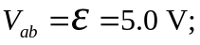 since there is no current there is no voltage lost over the internal resistance.
c) The voltmeter reading is therefore 5.0 V since with no current flowing, it measures the terminal voltage of the battery.

